**Cart management**

The architecture that is intended to be achieved in given below:

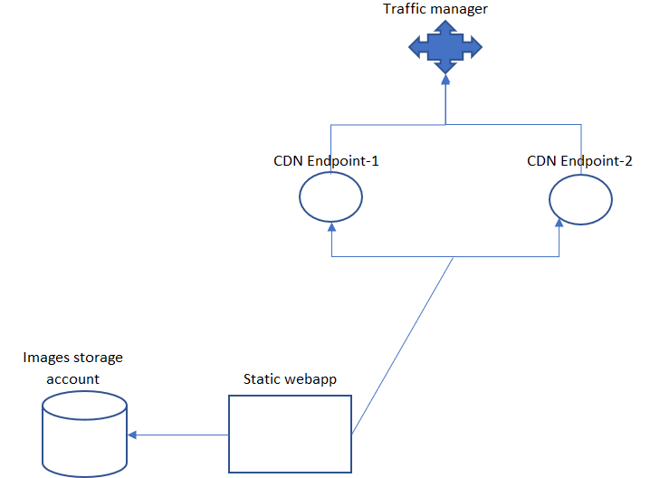

**Create storage account for images upload**:

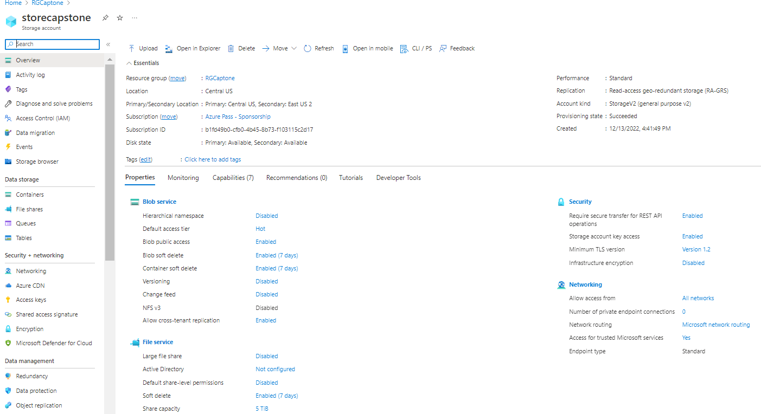

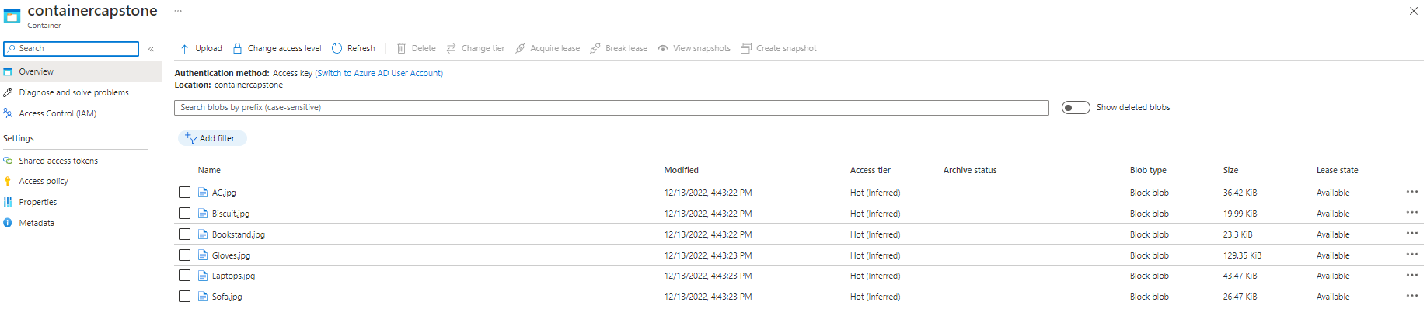

**Create Static Web App with continuous deployment towards github**

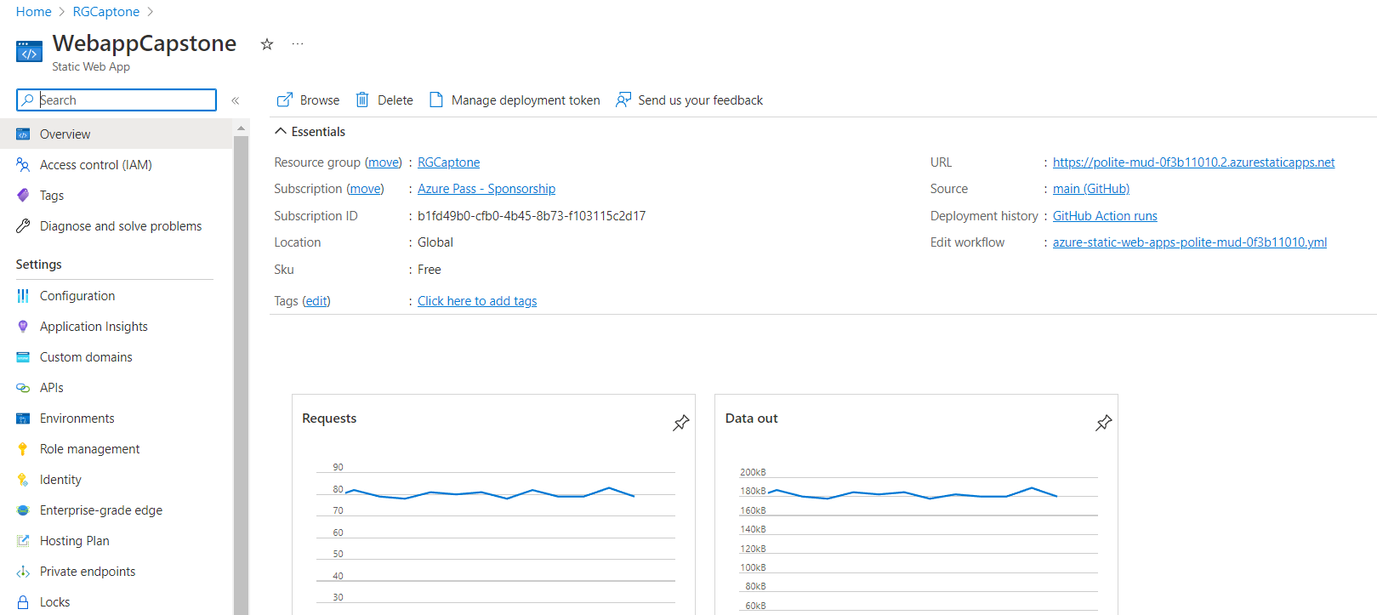

**Testing WebApp URL**  
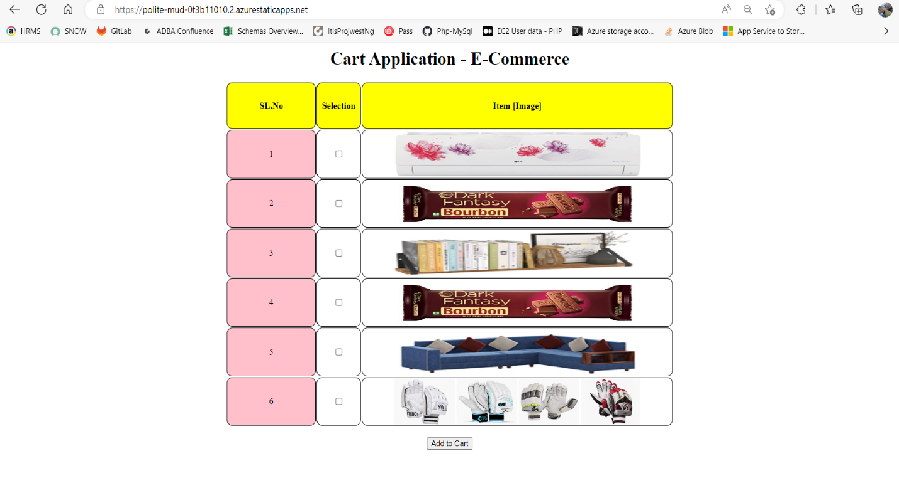

**Create 2 CDN Endpoints**  
  
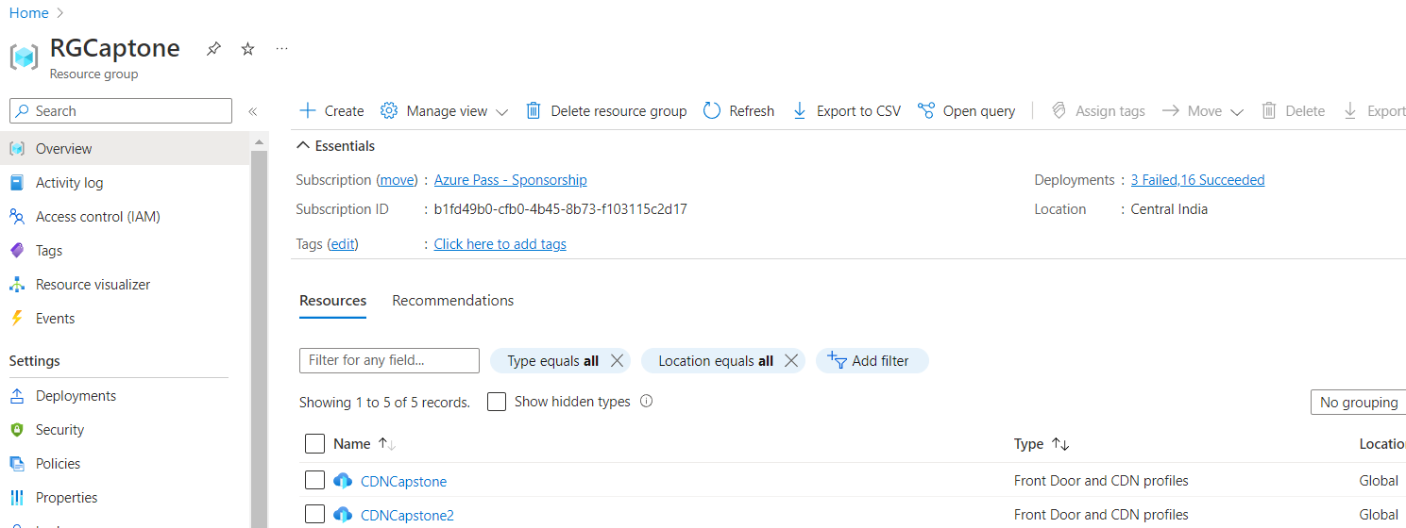

**CDN Endpoint-1**  
  
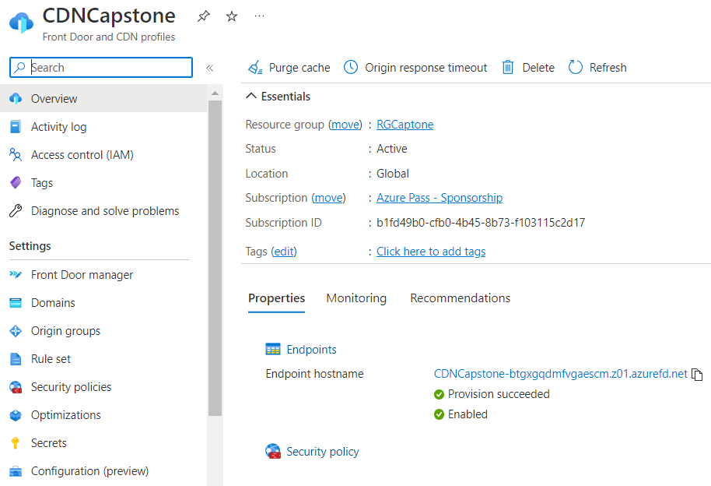

**Origin group mapping – Static web app URL**

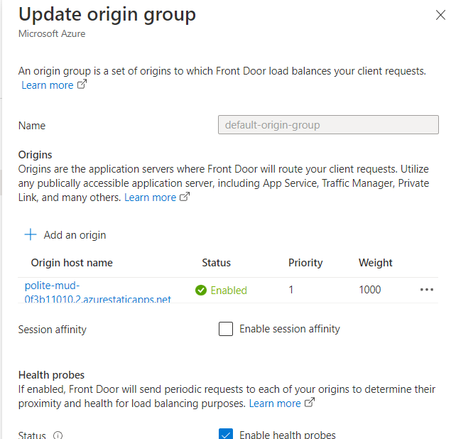

**Testing CDN end point-1**

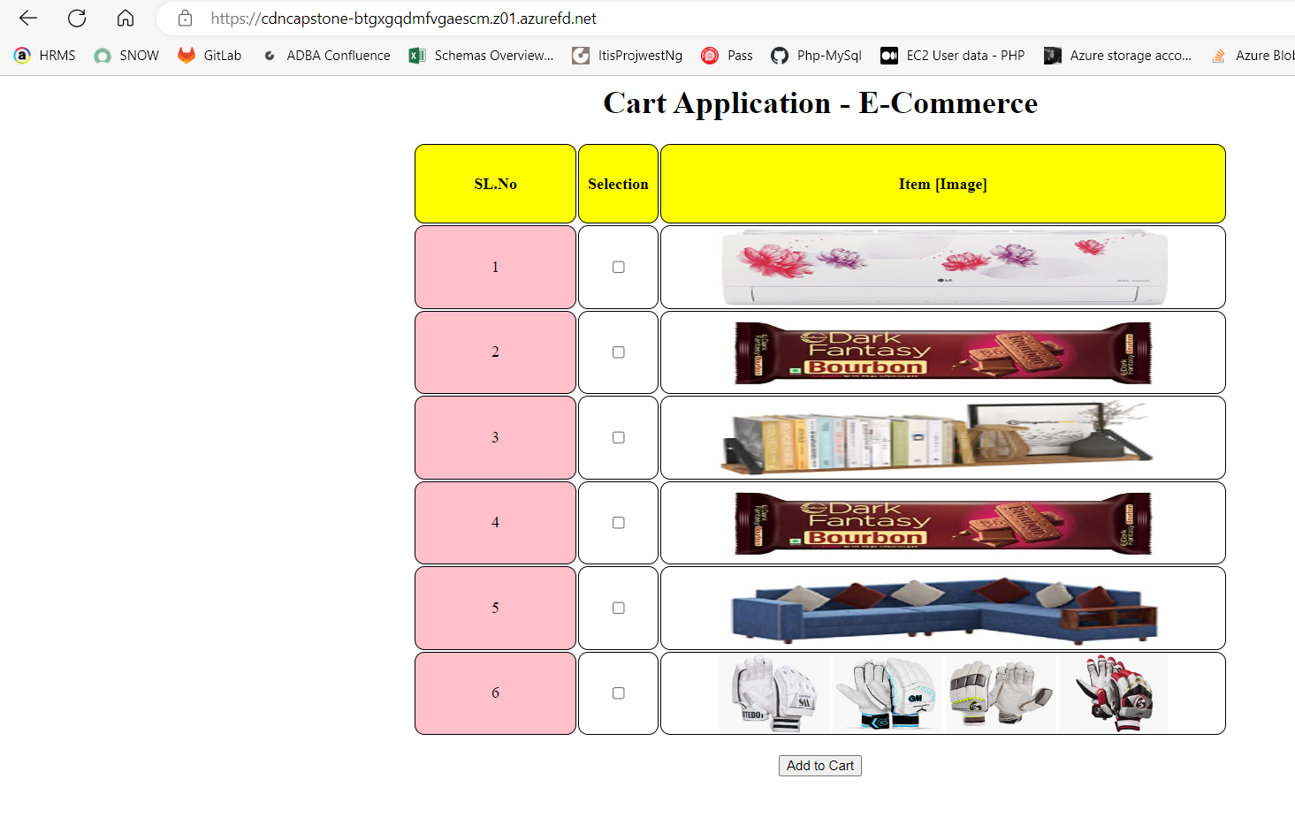

**CDN Endpoint-2**

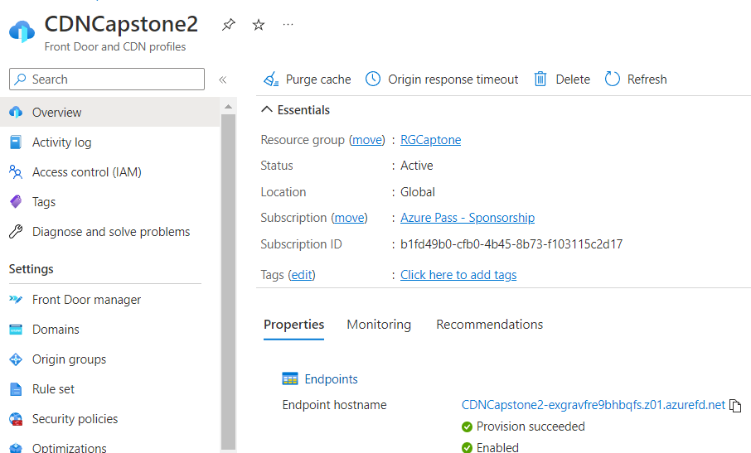

**Origin group mapping – Static web app URL**  
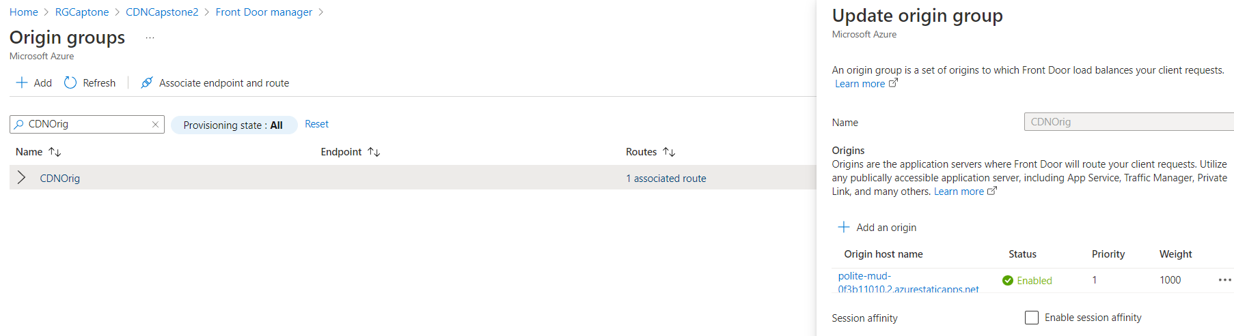

**Testing CDN end point-2**

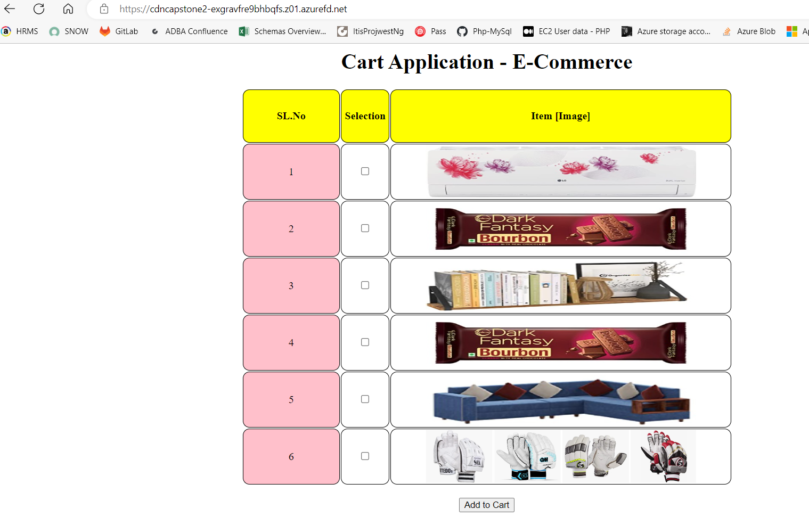

**Traffic Manager creation and CDN end point configuration**

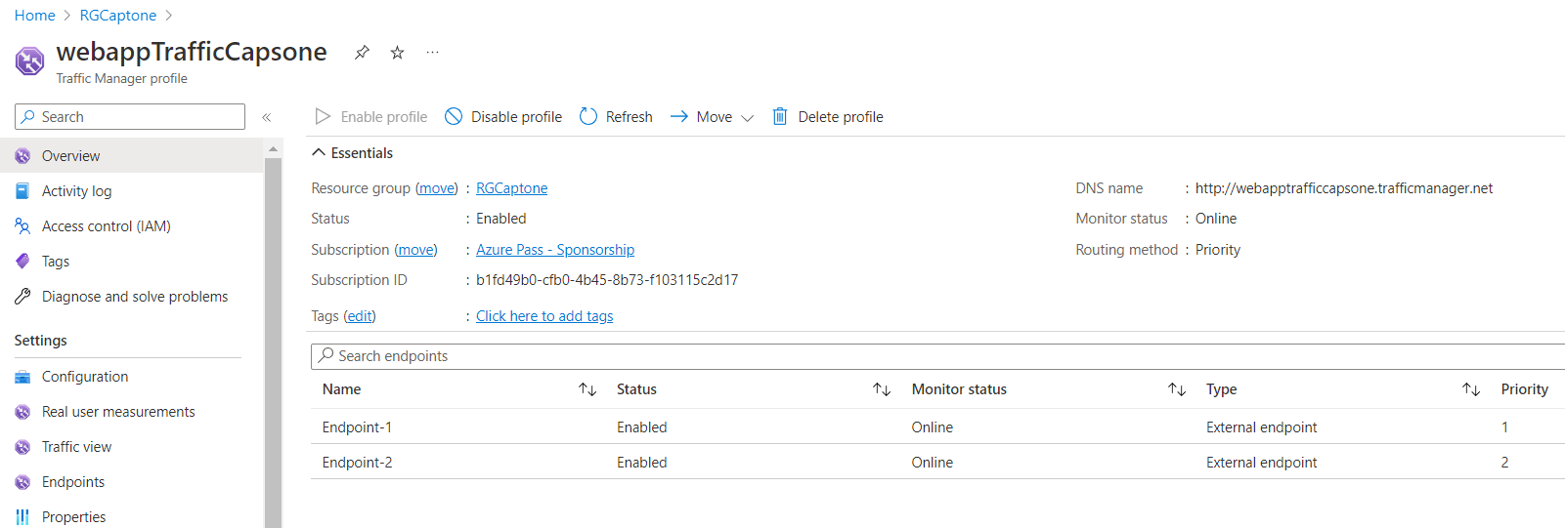

**Endpoint-1 = CDN-1 end point  
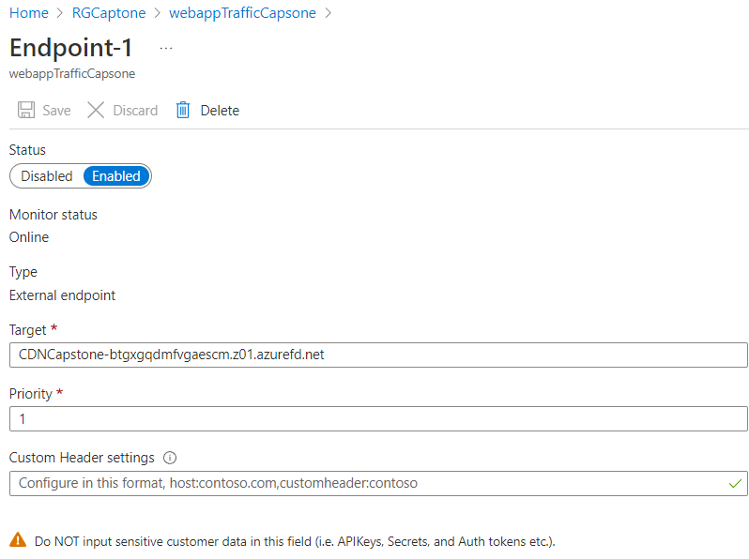  
Endpoint-2 = CDN-2 end point**

